Getting Started – Downloading and Installing the Trial Version of Photoshop Elements 7 and setting up your computer

Welcome to Beginning Photo Editing with Photoshop Elements at Get It Scrapped! Are you a beginner who is interested in trying your hand at editing your photos? You’ve come to the right place! You’ll be cropping, sharpening and otherwise editing your photos soon! Our “Getting Started” guide will have you ready to go when the first class is posted. This guide covers the software you’ll need, along with how to obtain and install it if necessary. Screenshots demonstrating techniques contained in the handouts will be created using Photoshop Elements 7. If you own Photoshop (Versions CS through CS4) or Photoshop Elements (Versions 3 through 7) you’re good to go! You may have to search around a little for the menus and tools that we are using though. For some reason, each time it redesigns its product, Adobe feels compelled to move things around!

If you don’t own either program, don’t despair. We don’t expect you to run out and buy software before you even decide if photo editing is for you! You can download a fully functional 30 day trial version of Photoshop Elements 7 from Adobe . The trial period is good for 30 days from the time you install the program, so I would advise that you go ahead and download the trial, but don’t install it until just before class starts!

To download an Adobe trial:
- Go to www.adobe.com/downloads. You will see “Adobe Photoshop Elements 7” under “Featured Product Downloads.” Hover over the blue box with the PSE inside and click on the word TRY. This will take you to a screen where you will need to log in with your Adobe ID (If you don’t already have an Adobe ID, you will have to register for one.
2. Download ... it’s quick, easy and free ... no strings attached! Click on the “select” box to choose the appropriate platform and language. Click the Download button. Your download will begin. Following the directions on your screen, download this .exe file to your desktop or to another location.

Install PSE 7.0 trial on Windows
When you are ready to install your PSE 7.0 30 day trial, click on the .exe file and follow the directions on your screen for installation. That’s it ... Photoshop Elements 7 is now installed on your system! Pat yourself on the back and get ready to learn how to set up your workspace in Photoshop Elements.

Setting up your workspace
We’re going to set up three things.
- When you open Photoshop Elements 7.0, choose “Edit” from the choices near the top of the page and that will bring you to the main workspace. The Editor workspace provides three ways to create and edit images: Full Edit, Quick Fix, and Guided Edit. (These are located near the top right of your workspace.) The Full Edit workspace has tools to correct color problems, create special effects, and enhance photos. This is where we will start. You will see these three choices near the top right of your screen. Choose “Full.” Later on we’ll talk about the Quick Fix and Guided Edit but we’ll start with Full Edit.
- At the bottom of the page is something called the Project Bin. It can cause a problem if you don’t have experience working with it, so we’re going to hide it. Look at the very bottom of the page on the very left side. If it says, “Hide Project Bin,” click on it. If it says, “Show Project Bin,” leave it alone.

3. The workspace is very dark and this bothers me. Some of you might not find this to be a problem at all. However, if you would like to lighten the workspace background (interface), it is possible by following these directions:
In the toolbar at the top of the page go to Edit>Preferences>General. Near the bottom, under Appearance Options, you will see the User Interface Brightness slider. Slide it all the way to the right. Click OK.

Your workspace should look like this:
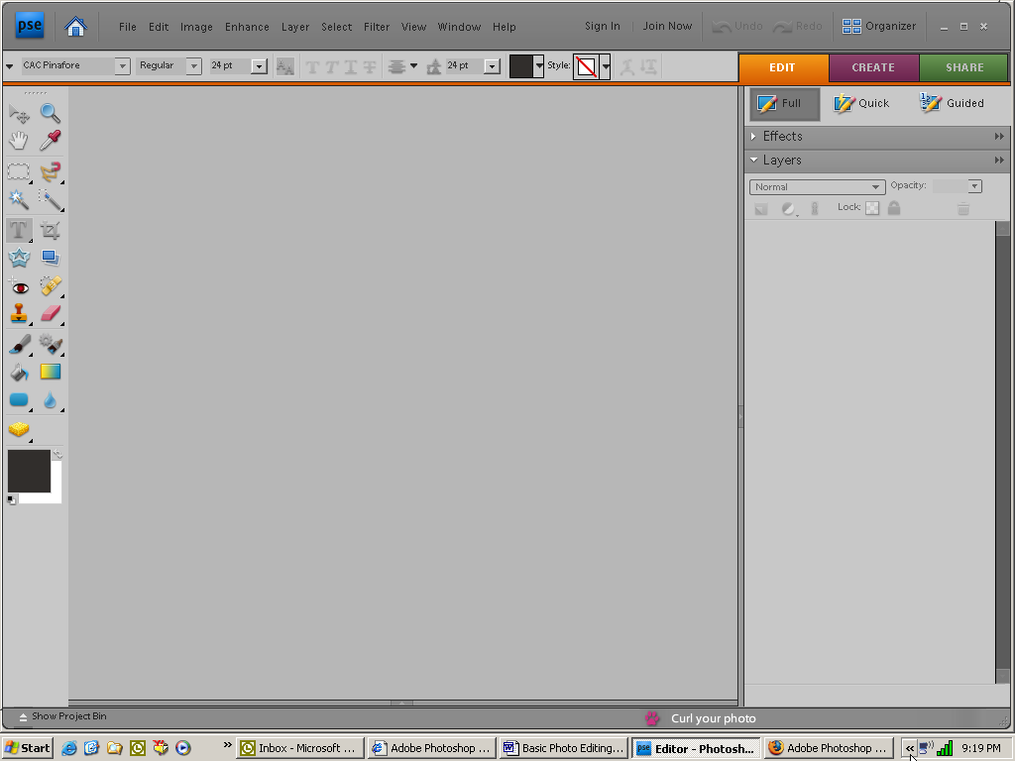

Download Photos to your computer
The only other thing you need to do to be ready for the class is to be sure that you have photos downloaded to your computer and saved in a location where you can find them.

Just a word of warning:
Photoshop Elements includes an organizer which is very handy for tagging and organizing your photos. We won’t be talking about the Organizer during this class. Sometimes during the editing process, a box will pop up that looks something like this:

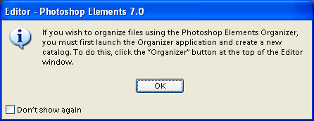
When this happens, you can either just Click OK and it will go away for a while or you can check the “Don’t show again” box and it won’t pop up again. So be forewarned!

We are now ready for Lesson *1—Cropping your images!

